Created by: David Rubio G.
Blog: https://soceame.wordpress.com/
GitHub: https://github.com/DRubioG
Last modification date: 10/03/25

This entry is created because every time you create a new project in SoftConsole for SmartFusion2 you always have to configure the same parameters. So, this entry is a compilation.

Compilation
A typical problem with SoftConsole is creating a project, and when you go to compile it, it generates a compilation error. This is because you have not configured 3 compilation directives that are always the same.
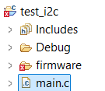
To do this, right-click on the project and click Properties. In the tab that opens, go to C/C++ Build and Settings.
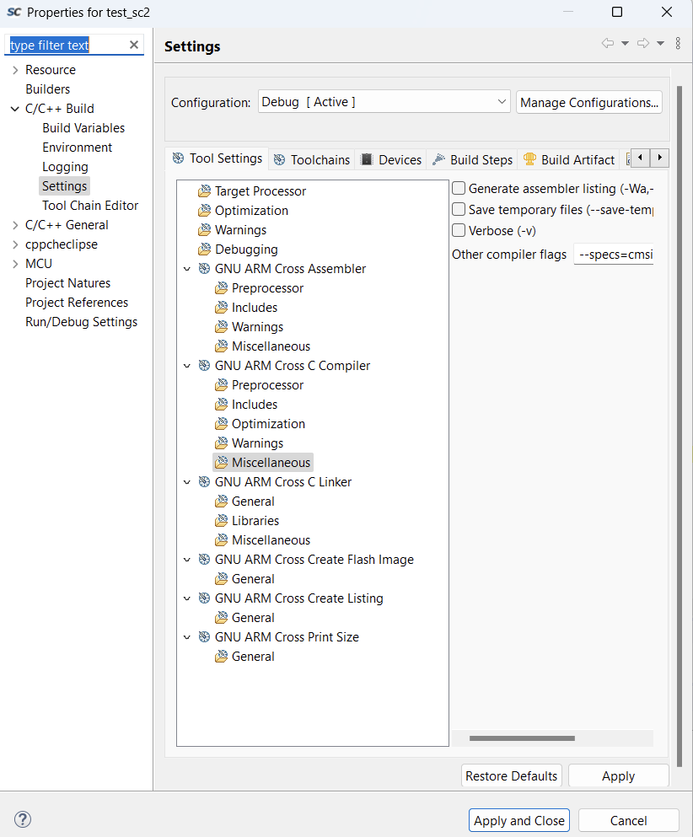
Now we configure the following options.
- In GNU ARM Cross C Linker, we check the box «Use newlib-nano (–specs=nano.specs)«.
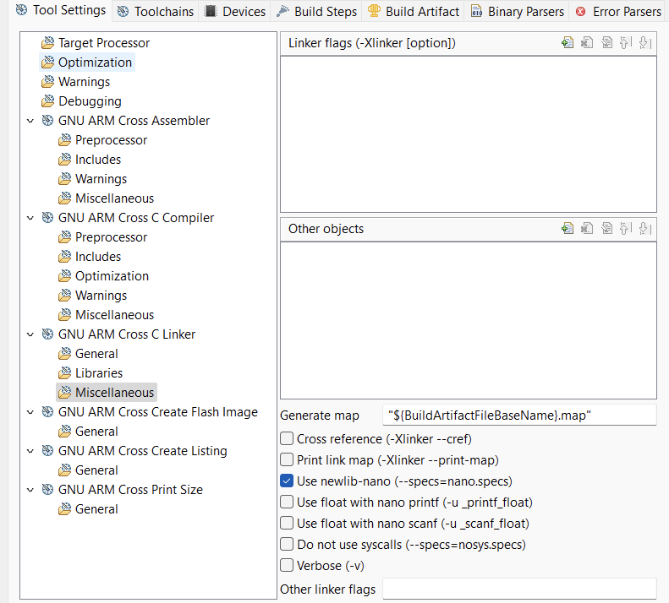
- In GNU ARM Cross C Compiler, we add the flag «–specs=cmsis.specs«.
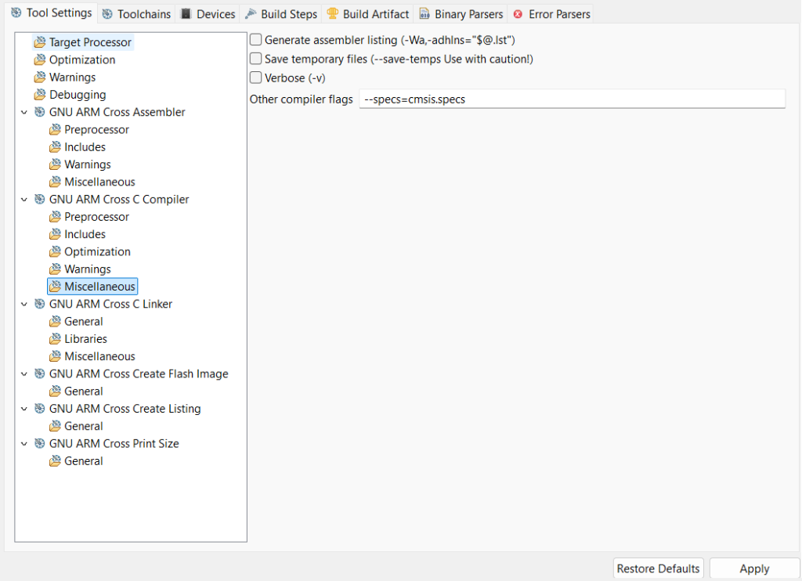
- In GNU ARM Cross C Linker we have to add how we are going to record the SoC memory with the SoftConsole executable. This is because the SoC is made with Flash memory, so you have to choose whether you want to save or delete the SoftConsole executable.
To add the option, click on the ‘+’.
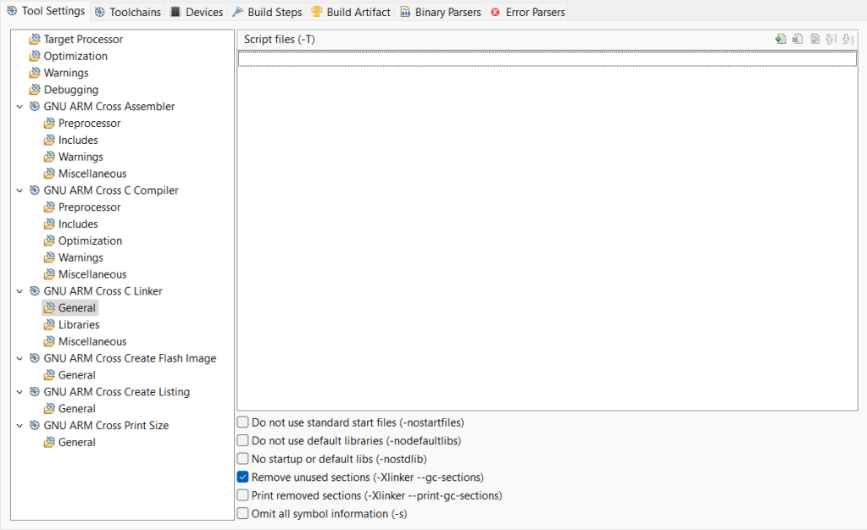
Then, a tab like this opens, then, click on Workspace….
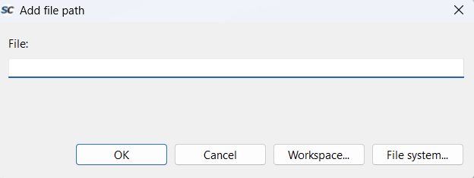
This opens a tab like the following, then, we have to go to the project drivers folder, and look in CMSIS > startup_gcc. Here you will see some .ld type files, these are the files that choose how the SoftConsole binary is saved.
We mainly focus on two:
- debug-in-microsemi-smartfusion2-envm.ld : this is the one that saves the SoftConsole binary in the internal non-volatile memory. Because the program is saved.
- debug-in-microsemi-smartfusion2-esram.ld : this is the one that writes the binary to SRAM memory, so resetting or cutting off the power will make the program disappear.
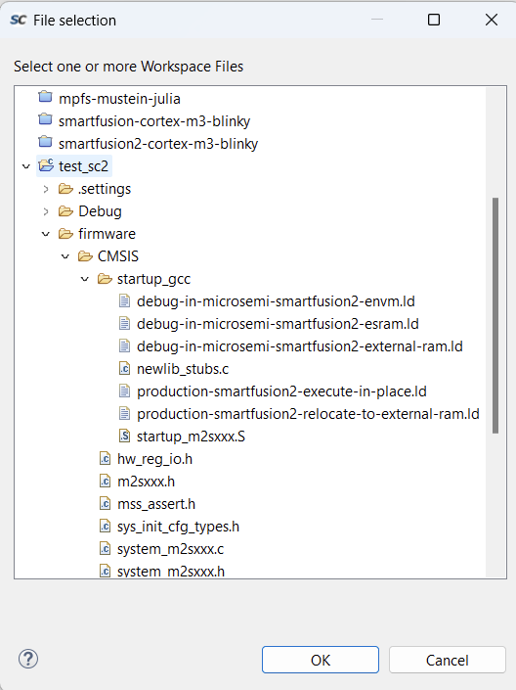
Once selected, it appears in the next tab.
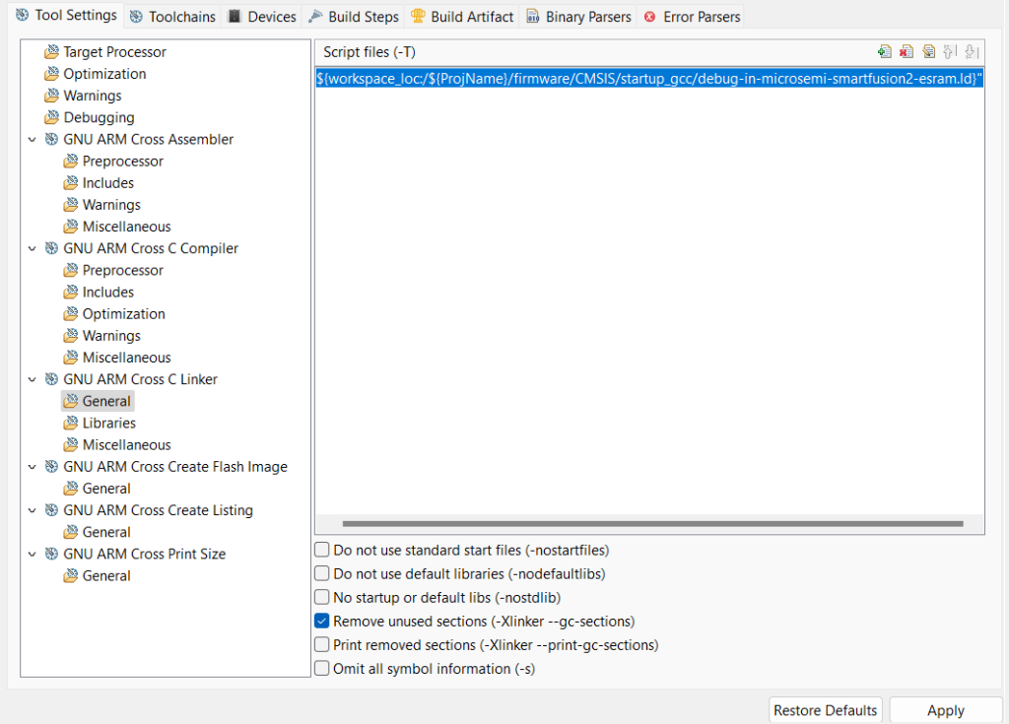

Debugging
For debugging, the first thing you have to create is a new debug profile that includes the .elf you want to debug.
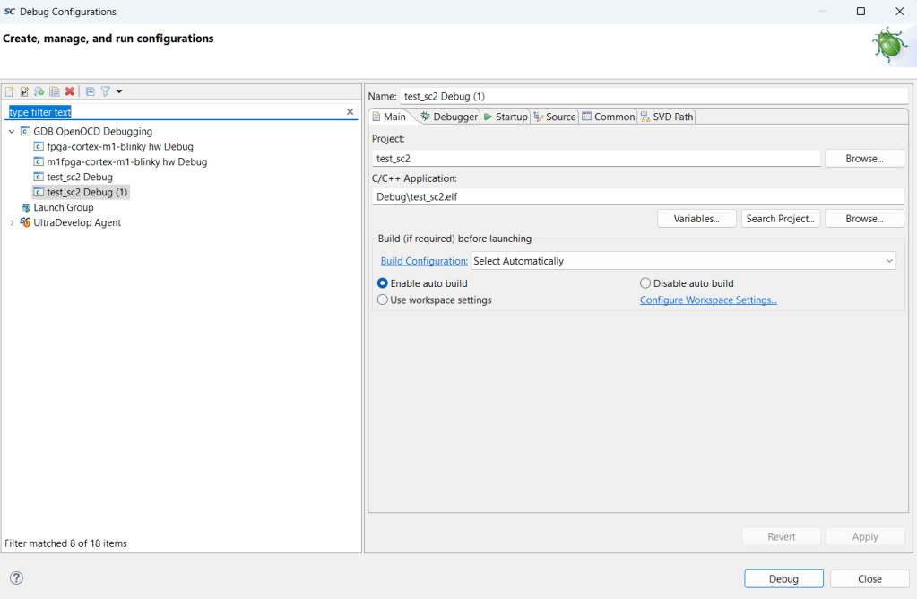
In the debugger tab, you have to fill in the OpenOCD Setup box with the following settings: –command «set DEVICE <Microsemi device>» –file board/microsemi-cortex-m3.cfg
(in my case, since I’m going to program an M2S010, I put it as a value).
And in the GDB session box, I leave the following command: set mem inaccessible-by-default off
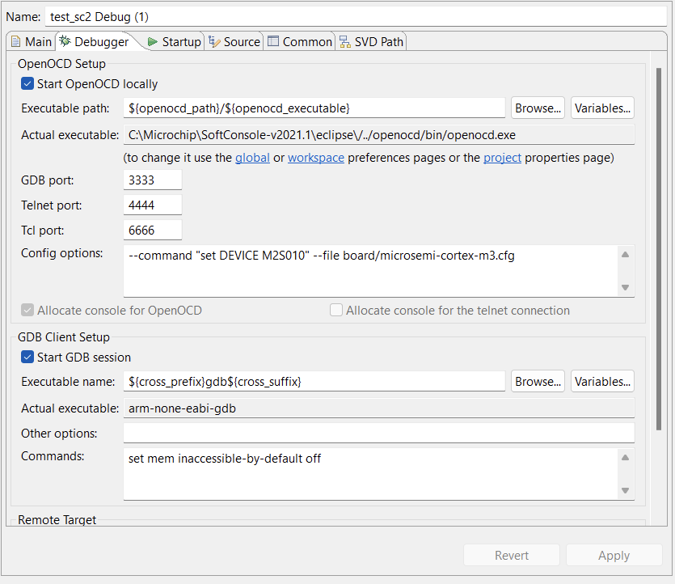
Finally, in the Startup tab, you have to have the Pre-run/Restart reset box unchecked.
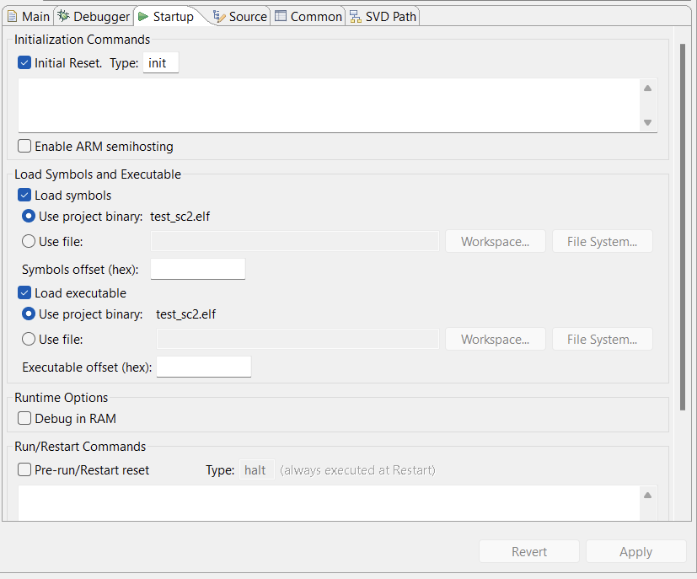
Now you can launch debugging. To know what you are debugging you can see it in the Debug tab of the SoftConsole.
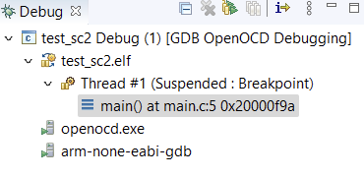

Final NOTE
If you try to launch a new debugging while the board is debugging another program, an error will appear and you will be taken out of debugging, having to launch the debugging again.
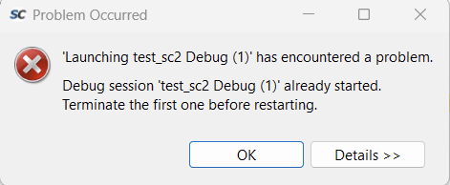
To avoid this error, what you can do is right click on the debugging that is running and click Terminate and Relaunch. This will not take you out of debugging.
NOTE: remember to compile the program before launching it again in debugging.
